5 Negative Effects of High Overtime Levels

Overtime can be beneficial for both employees and companies. It provides the company with the flexibility to cover unexpected absences and changes in demand without hiring more staff and it gives employees extra income at a premium rate.

However, overtime has its downsides too. While many employees will happily take as much overtime as is available, there is growing scientific evidence that relying too much on overtime can lead to numerous problems for an operation.

Below are five consequences to relying on excessive amounts of overtime:

#1 - Increased Health Problems

A considerable body of scientific work has explored the health problems associated with working excessive overtime. Some health problems that have been linked to long working hours include: 7-11

• Lower-back injury in jobs with a lot of manual lifting

• Higher blood pressure among white-collar workers

• Increased mental health issues

• Increase in total and lost workday injury rates

• Lower birth weight or gestational age in women

• Heavy alcohol consumption among men

• Higher suicide rates

A study by Cornell University shows that approximately 10% of employees who work 50 to 60 hours per week report severe work-family conflicts.12This number jumps to 30% for those who work more than 60 hours. The divorce rate also increases as weekly hours increase. These factors contribute in turn to mental health and alcohol problems.  
  
A Canadian study showed that workers who increased their work hours from 40 hours or less per week to over 40 hours per week experienced an increase in tobacco and alcohol consumption, an unhealthy weight increase among men, and an increase in depression among women. 13These health problems contribute to the indirect costs of allowing excessive overtime to occur. Health care costs, absenteeism, and turnover will increase, while productivity will decrease.

#2 - Increased Safety Risk

Long work hours have been linked to increased safety risk in several studies (reviewed by

Rosa), including: 11

* Safety and performance at nuclear plants
* Impaired performance and lowered attention
* An increase in errors in medical facilities
* A threefold increase in accident rates after 16 hours of work

These additional safety problems are likely due to worker fatigue, which could be from a single long day or from the cumulative effect of multiple days of long hours. A German study showed that doctors who worked over 48 hours a week were five times more likely to have a driving accident (either while traveling to a call, or while commuting). 14While working at night and during the early morning has been linked to an increased risk of transportation accidents, research also suggests that long work hours in themselves contribute to accident rates.15 As they become more fatigued, drivers become less cautious, execute more dangerous maneuvers, and exhibit more erratic driving patterns.  
  
Circadian data from shift work operations (not just transportation operations) shows that companies with more fatigue-related problems are also likely to have higher rates of overtime (Figure 6), emphasizing the effect that longer work hours can have on sleep quantity and quality.

**Figure 1. Level of fatigue-related workplace problems versus overtime level** 3  
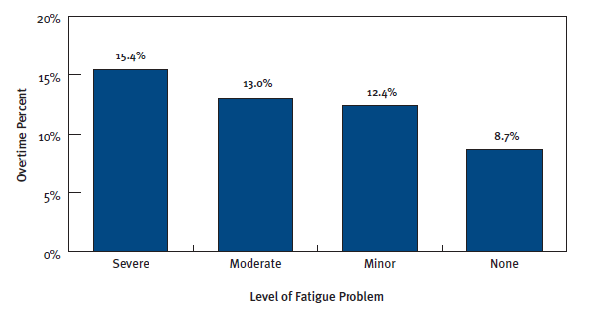

#3 - Decreased Productivity

Studies and reports suggest that productivity can suffer with increased overtime hours. In white-collar jobs, performance decreases by as much as 25% when 60 or more hours are worked in a week. 16 Any job not governed by a continuous process can be affected by decreased productivity, and even process-driven work can suffer if reject rates and customer dissatisfaction increase due to diminished quality and performance linked to long hours.

This performance decline is confirmed by the work of J. Nevison of Oak Associates. In his white paper, Nevison brings together scientific, business, and government data to demonstrate that little productive work takes place over and above 50 hours per week (Figure 2). Two other studies, also examined in the white paper, show that productive hours drop by an additional 10 hours when the number of consecutive long workweeks increases from four to 12, highlighting the cumulative effects that overtime can have.

**Figure 2. Productive vs. actual work hours, from a collection of four studies**16

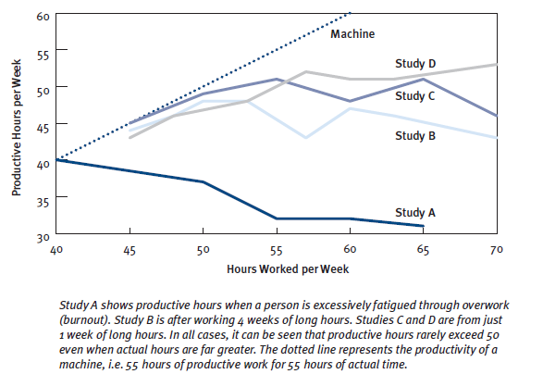

Data from 18 manufacturing industries in the U.S. shows that for most of these industries, productivity (measured as output per hour) declines when overtime is used.17On average, a 10% increase in overtime results in a 2.4% decrease in productivity (more output is achieved, but the number of hours worked increases as well—not as much output per hour is realized).

The scientific literature gives the following reasons for the productivity limitations of longer and longer workweeks:

* Fatigue—employees simply being too physically and mentally tired to perform at their best ability
* As more time is provided or available to complete a task, work rate slows and unproductive time increases
* Concerns over work/family balance and health problems may lead to presenteeism— where the employee is physically at work, but his or her mind is not on the job
* If employees are working long workweeks simply to be seen “putting in the hours,” it is likely that these hours are less productive

In shift work operations, morale is lower in industries with higher overtime—companies with excellent to fair morale had overtime levels of 11.5% versus 15.5% in those with poor or very poor morale (Figure 3).3

**Figure 3. Overtime and morale in a facility.**3

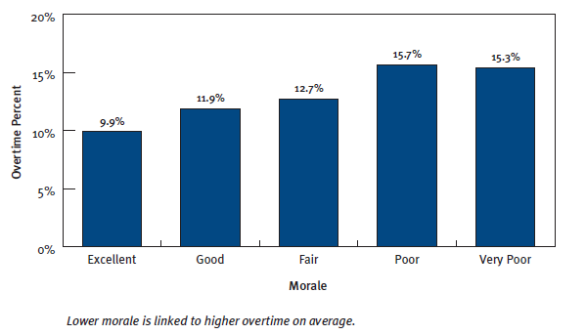

#4 - Increased Absenteeism

Excessive overtime can lead to absenteeism as a result of poor health, fatigue, or people simply needing to take time off. Absences often need to be covered by replacement employees, often working overtime themselves, making the problem self-perpetuating.

Excessive overtime can also result in morale problems, which can be manifested as low productivity, absenteeism, turnover and labor issues. In Circadian’s Shiftwork Practices 2004, 31% of shift work companies with very high overtime levels (more than 10 hours per employee per week) had poor morale. Conversely, only 13% of companies with normal overtime amounts had poor morale. Morale was reflected in absenteeism levels: 54% of operations with high overtime also had absenteeism levels above 9%, compared with only 23% of operations with normal levels of overtime.

This is not to say that all absenteeism is a result of employee response to overtime—companies with high absenteeism will often use overtime to fill vacancies. However, it is likely that the problem is self-perpetuating to some degree.

#5 - Increased Turnover Rates

It follows that another adverse effect of excessive absenteeism will be increased turnover, as the lack of work-life balance and fatigue resulting from excessive overtime finally catch up with some employees. Again, as with absenteeism, companies with high turnover are also likely to have high overtime, as employees must work to make up for vacant positions if demand is to be met.

Turnover as a direct result of working excessive hours is more likely in non-hourly positions, where the employees are not being paid a premium to work the extra hours.

Solutions

While there are clearly a myriad of issues associated with employee overtime rates, there are a variety of ways to mitigate the negative effects of overtime. The proper solutions for managing overtime can vary based on industry, company size, work environment, and many other factors. It is key to recognize that overtime policies should be regularly assessed to determine their effectiveness.

Managing Overtime

To properly manage the direct and indirect costs associated with excessive overtime, employers should do the following:

• Reduce unscheduled absences by addressing the root cause(s) of them.

• Ensure staffing levels are appropriate and that they meet varying demand through the day, week, month and year.

• Review policies and procedures to ensure that they do not encourage excessive overtime.

• Take steps to increase productivity during the regular workweek.

Choosing Appropriate Level of Overtime

The appropriate level of overtime for a particular facility depends on a number of factors, including whether your employees must be paid an overtime premium, training and recruitment costs, safety and quality issues, and the cost of the benefits package.